Martin Luther King Jr – Malcolm X

Part II: Explore the Key Idea: Write 5-7 sentences on what is the best way to fight against injustice?
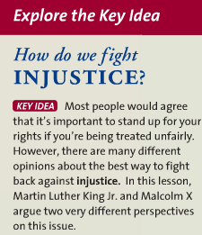

Part I: Background Info: Write 2 important details from each of the sections on MLK and Malcolm X. See page numbers.

MARTIN LUTHER KING JR.
Pg. 1144

Boycott in Montgomery

Expanding Influence

Warrior for Peace

MALCOLM X
Pg. 1160

Bitter Legacy

Change of Heart

Marked Man

